|  |  |
| --- | --- |
| Use Case UC-1： | Registration |
| Related Requirem’ts: | REQ1 |
| Initiating Actor: | User |
| Actor‘s Goal | Users can register their own account password on the website and can log in successfully. |
| Participating Actors: | Database, users |
| Preconditions: | User opens the website registration page |
| Postconditions: | nothing worth mentioning |
| Flow of Events for Main Success Sccnario: | 1: User enters his own account, password  2: User registration information is stored in the database |

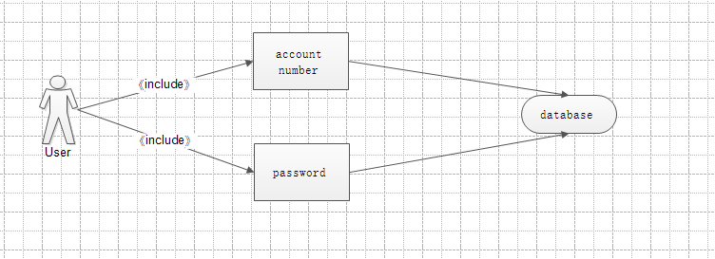

|  |  |
| --- | --- |
| Use Case UC-2： | Login |
| Related Requirem’ts: | REQ2 |
| Initiating Actor: | User |
| Actor‘s Goal | Users enter their own account password into the website system |
| Participating Actors: | Database, users |
| Preconditions: | The password account is successfully registered. |
| Postconditions: | nothing worth mentioning |
| Flow of Events for Main Success Sccnario: | 1: User input account password  2: Click the OK button |

